
Tertiary Infotech Academy Pte Ltd
UEN: 201200696W
LEARNER GUIDE
For
SQL Masterclass
Course Code: C024
Conducted by
Tertiary Infotech Academy Pte Ltd
UEN: 201200696W
Version 1

DOCUMENT VERSION CONTROL RECORD
Version Number | Effective Date of Release | Summary of Included Changes | Author
1.0 | 2 October 2026 | Initial release of the SQL Masterclass learner guide: step-by-step instructions for all 11 hands-on labs, SQL quick reference and glossary. | Dr. Alfred Ang

TABLE OF CONTENTS
Introduction 4
Course Learning Outcomes 4
Before You Start — Environment Setup 4
The Course Data — SG Mart Pte Ltd 5
Topic 01 — Data Modeling 7
Lab 1 — Set Up SQLite Studio & Import the SG Mart Database 7
Lab 2 — Create a Database and Tables 9
Lab 3 — Model Data with Constraints and Keys 13
Topic 02 — Data Processing and Analysis 17
Lab 4 — Query Data with SELECT 17
Lab 5 — Filter with SQL Operators 19
Lab 6 — Insert, Update and Delete Records 22
Topic 03 — Data Transformation 25
Lab 7 — Aggregate Data with COUNT, AVG and SUM 25
Lab 8 — Join Data from Multiple Tables 28
Lab 9 — Group Data with GROUP BY and HAVING 32
Topic 04 — Introduction to Data Warehouse 35
Lab 10 — Map an E-R Model to Database Tables (SMRT Case Study) 35
Lab 11 — Author Stored Procedures for SQL Server 40
SQL Quick Reference 43
After the Course 45
Glossary 45

Introduction
This Learner Guide accompanies the course SQL Masterclass (C024), conducted by Tertiary Infotech Academy Pte Ltd. It provides detailed step-by-step instructions for all 11 hands-on labs, organised by the four course topics: Data Modeling, Data Processing and Analysis, Data Transformation, and Introduction to Data Warehouse. Every lab runs in SQLite Studio (or the free sqliteonline.com) against the SG Mart mock database supplied with the course.
Use this guide alongside the course slides and the lab files in the labs/ folder of the course repository. The slides present each concept and lab visually; THIS guide carries the full step-by-step SQL for you to type and run.

Course Learning Outcomes
- LO1: Apply data modeling for business processes.
- LO2: Apply data processing and analysis using SQL.
- LO3: Apply data transformation from multiple data sources.
- LO4: Apply data mapping to data warehouse.

Before You Start — Environment Setup
What you need
- SQLite Studio — free, open-source, cross-platform. Download from https://sqlitestudio.pl and install for your OS.
- No-install alternative: the free cloud editor at https://sqliteonline.com (also offers an MS SQL engine for the stored-procedure lab).
- The course mock data — download the labs/_all folder from the course repository at https://github.com/tertiarycourses/C024-SQL-Masterclass. It contains a prebuilt sgmart.db database, an Excel workbook and CSV files for every lab.
- Any laptop OS — Windows, macOS or Linux.

The Course Data — SG Mart Pte Ltd
Every lab in this course works with one continuous business story so you are always querying something that means something. SG Mart Pte Ltd is a fictitious Singapore retail chain with eight outlets. You will model its shops, staff, members, suppliers and products, then analyse a full year of its sales. Topic 4 switches to an SMRT public-transport model for the data-warehouse case study.
Note: All of this data is invented for training purposes. The names, phone numbers, email addresses and badge numbers do not identify any real person or organisation, and the SMRT figures are illustrative rather than operational records.
The tables you will work with
Table | Rows | What it holds
Outlets | 8 | The 8 SG Mart retail outlets — code, name, planning area, postal sector, opening date and floor area.
Categories | 8 | 8 product categories grouped into Perishables, Packaged and Non-Food.
Suppliers | 9 | 9 suppliers with contact details, country of origin and lead time in days.
Customers | 60 | 60 loyalty members — tier, join date, points, birth year (some NULL) and home district.
Staff | 42 | 42 employees across the 8 outlets — role, salary, hire date and contact details (some emails are NULL on purpose).
Products | 25 | 25 SKUs with cost, retail price, category, supplier and reorder level (some NULL).
Orders | 180 | 180 sales orders across 2025 — outlet, member (NULL for walk-ins), cashier, channel, payment and status.
OrderItems | 685 | Order lines (the fact table) — quantity, unit price, discount and line total. Makes SUM/AVG/GROUP BY meaningful.
Routes | 8 | 8 SMRT routes (6 MRT lines + 2 bus services) — the parent entity of the transport E-R model.
Stations | 14 | 14 MRT stations with line position, interchange flag and opening date.
Timetables | 42 | 42 timetable rows — first/last trip and frequency per station for weekday, Saturday and Sunday/PH.
DisruptedRoutes | 6 | 6 service disruptions in 2025 — type, details, start time, duration and the alternative arrangements offered.

How the tables relate
- Outlets 1—many Orders — every sale is rung up at one branch.
- Customers 1—many Orders — members link to their purchases; walk-in orders have a NULL CustomerID, which is what makes the LEFT JOIN lab meaningful.
- Staff 1—many Orders — the cashier who served the customer; each staff member belongs to one outlet.
- Orders 1—many OrderItems — the order header and its lines. OrderItems is the fact table: one row per product sold, carrying quantity, price, discount and line total.
- Categories 1—many Products and Suppliers 1—many Products — the two ways the range is classified.
- Routes 1—many Stations and 1—many Timetables; Timetables 1—many DisruptedRoutes — the SMRT chain used in Lab 10.
Where to find it
- Each lab has its own folder under labs/ holding the instructions, the tables that lab needs as CSV, and the seed scripts — all together.
- seed_sqlite.sql creates and fills every table for that lab in one execution — this is the fastest way to start.
- seed_mysql.sql is the same data in MySQL / SQL Server syntax, used for the stored-procedure lab.
- labs/_all/ holds the complete set: SG-Mart-Mock-Data.xlsx (one sheet per table), the prebuilt sgmart.db, and every CSV.
A note on empty values
Some columns are deliberately left empty: a few staff have no work email, some members declined to give a birth year, two products have no reorder level, and seventeen orders were walk-in sales with no membership attached. These gaps are intentional. They are what let you practise IS NULL, see how COUNT() skips NULLs, and understand why a LEFT JOIN returns rows an INNER JOIN would silently drop.
Set up SQLite Studio
Install SQLite Studio, then connect a database: Database → Add a database, browse to a .db file (or click the green '+' to create a new one) and Connect to the database from the left-hand Databases panel. Open the query editor with Tools → Open SQL editor and check the active database shown at the top of the editor.
Conventions used in every lab
- SQL statements are shown in code blocks — type or paste them into the SQL editor and press the Execute (▶ / F9) button.
- SQL keywords are shown in UPPERCASE by convention; SQLite accepts any case.
- Statements end with a semicolon; you can run several statements together.
- Labs 1–10 use SQLite; Lab 11 (stored procedures) uses SQL Server syntax — author it on sqliteonline.com's MS SQL engine.
- If a query fails, read the error message at the bottom of the editor — it names the offending token.

Topic 01 — Data Modeling
Data Sources · Data Modeling · SQL Data Types · Create & Manage Databases
Key concepts
- Relational databases — A database is one or more tables; each table is rows (records) and columns (fields) with a fixed row type.
- DDL statements — CREATE / ALTER / DROP define databases, tables, indexes and their columns and data types.
- Constraints — NOT NULL, DEFAULT, UNIQUE, CHECK, PRIMARY KEY and FOREIGN KEY enforce rules on the data.
- Data modeling — Primary and foreign keys link tables into entity relationships that mirror the business process.

Lab 1 — Set Up SQLite Studio & Import the SG Mart Database
Objective: LO1 — identify relevant data sources and set up the SQL workbench.
Goal: Install SQLite Studio, connect it to the SG Mart sample database and explore its tables — your data source for the whole course.
What you'll build
A working SQLite Studio with the SG Mart database connected, showing the Outlets, Products and Categories tables. (Tools: SQLite Studio, sgmart.db mock database, course repository.)
Mock data for this lab
Load the data before you start. The tables below are supplied as CSV in labs/lab-01-*/ — the same folder as this lab's instructions — together with seed_sqlite.sql. Open that script in the SQL editor and execute it to create and fill every table in one step.
Table | Rows | What it holds
Outlets | 8 | The 8 SG Mart retail outlets — code, name, planning area, postal sector, opening date and floor area.
Products | 25 | 25 SKUs with cost, retail price, category, supplier and reorder level (some NULL).
Categories | 8 | 8 product categories grouped into Perishables, Packaged and Non-Food.

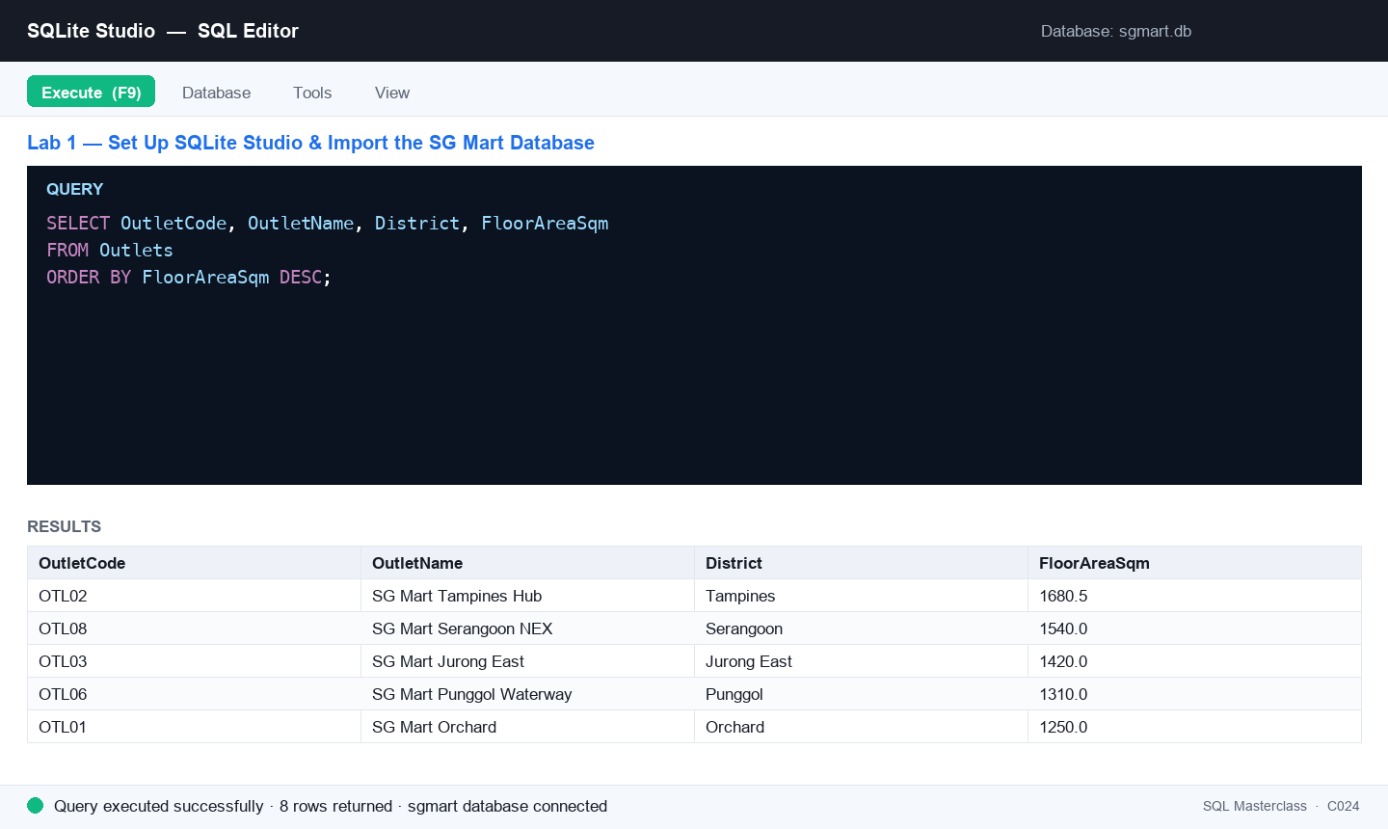
Figure 1 — Lab 1: the SQL editor after running this lab's key statement.
Step-by-step
Step 1. Download SQLite Studio for your OS from the official site and install it. (Alternative: use the free cloud version at sqliteonline.com — no install needed.)
https://sqlitestudio.pl
Step 2. Download the course mock data from the course repository. You want the labs/_all folder — it contains sgmart.db (a ready-built SQLite database), an Excel workbook and the CSV files.
https://github.com/tertiarycourses/C024-SQL-Masterclass
Step 3. Open SQLite Studio, click Database → Add a database, browse to the downloaded sgmart.db and click OK.
Step 4. In the left-hand Databases panel, right-click sgmart and choose Connect to the database.
Step 5. Expand the database tree. You should see the SG Mart tables — Outlets, Categories, Suppliers, Products, Customers, Staff, Orders and OrderItems. Double-click Outlets and open the Data tab to preview its 8 rows.
Step 6. Run your first query to confirm the connection works — list the retail outlets by floor area, largest first.
SELECT OutletCode, OutletName, District, FloorAreaSqm
FROM Outlets
ORDER BY FloorAreaSqm DESC;
Step 7. Open Outlets.csv from the datasets folder in Excel to see the same data as a spreadsheet. This is the raw form the business hands you before it becomes a table.
Test it
The Databases panel shows the connected sgmart database with the Outlets, Products, Customers, Orders and OrderItems tables; the Data tab displays outlet rows; and the ORDER BY query returns 8 outlets led by SG Mart Tampines Hub (1680.5 sqm).
Note: The same steps are in labs/lab-01-*/ in the course repository, alongside that lab's CSV data and SQL seed scripts.

Lab 2 — Create a Database and Tables
Objective: LO1 — create and manage databases and tables with SQL DDL.
Goal: Create your own database named 'sgmart_practice' and build the Outlets, Categories, Suppliers and Products tables with CREATE TABLE, choosing an appropriate data type for every column.
What you'll build
A new 'sgmart_practice' database containing four tables whose columns, data types and defaults model the SG Mart retail business. (Tools: SQLite Studio, SQL Editor, lab-02 dataset (CSV + seed script).)
Mock data for this lab
Load the data before you start. The tables below are supplied as CSV in labs/lab-02-*/ — the same folder as this lab's instructions — together with seed_sqlite.sql. Open that script in the SQL editor and execute it to create and fill every table in one step.
Table | Rows | What it holds
Outlets | 8 | The 8 SG Mart retail outlets — code, name, planning area, postal sector, opening date and floor area.
Categories | 8 | 8 product categories grouped into Perishables, Packaged and Non-Food.
Suppliers | 9 | 9 suppliers with contact details, country of origin and lead time in days.
Products | 25 | 25 SKUs with cost, retail price, category, supplier and reorder level (some NULL).

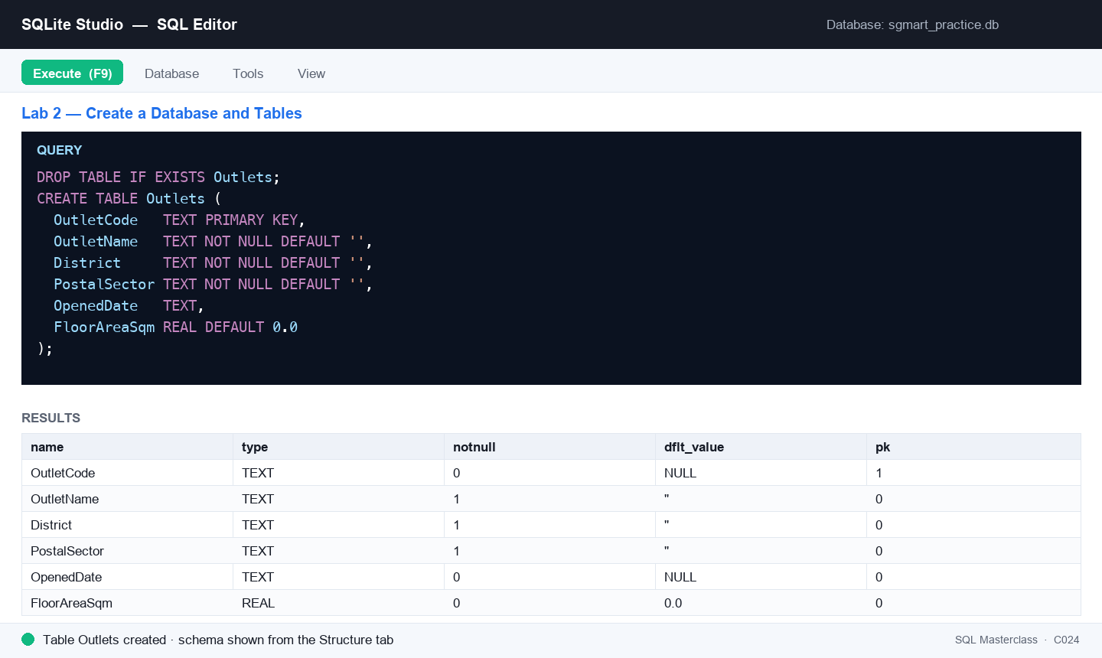
Figure 2 — Lab 2: the SQL editor after running this lab's key statement.
Step-by-step
Step 1. In SQLite Studio click Database → Add a database, then click the green '+' (plus) icon, name the new database file sgmart_practice and save it. Connect to it from the Databases panel.
Step 2. Open the SQL editor: go to Tools → Open SQL editor. Make sure the active database (top of the editor) is sgmart_practice.
Step 3. Create the Outlets table — the retail branches. Note the TEXT primary key and the REAL column for floor area.
DROP TABLE IF EXISTS Outlets;
CREATE TABLE Outlets (
OutletCode TEXT PRIMARY KEY,
OutletName TEXT NOT NULL DEFAULT '',
District TEXT NOT NULL DEFAULT '',
PostalSector TEXT NOT NULL DEFAULT '',
OpenedDate TEXT,
FloorAreaSqm REAL DEFAULT 0.0
);
Step 4. Create the Categories table — how SG Mart groups what it sells.
DROP TABLE IF EXISTS Categories;
CREATE TABLE Categories (
CategoryCode TEXT PRIMARY KEY,
CategoryName TEXT NOT NULL DEFAULT '',
CategoryGroup TEXT NOT NULL DEFAULT 'Packaged'
);
Step 5. Create the Suppliers table, including a lead time in days used later for reorder planning.
DROP TABLE IF EXISTS Suppliers;
CREATE TABLE Suppliers (
SupplierID TEXT PRIMARY KEY,
SupplierName TEXT NOT NULL DEFAULT '',
Address TEXT,
Phone TEXT,
Country TEXT NOT NULL DEFAULT 'Singapore',
LeadTimeDays INTEGER DEFAULT 14
);
Step 6. Create the Products table — the item master. Cost and price are REAL, IsActive is a 0/1 flag.
DROP TABLE IF EXISTS Products;
CREATE TABLE Products (
SKU TEXT PRIMARY KEY,
ProductName TEXT NOT NULL DEFAULT '',
CategoryCode TEXT NOT NULL DEFAULT '',
UnitOfMeasure TEXT NOT NULL DEFAULT 'each',
UnitCost REAL DEFAULT NULL,
UnitPrice REAL DEFAULT NULL,
SupplierID TEXT,
ReorderLevel INTEGER DEFAULT NULL,
IsActive INTEGER NOT NULL DEFAULT 1
);
Step 7. Load the mock data: open seed_sqlite.sql from this lab's dataset folder and execute the whole script. It fills all four tables. (Or use Tools → Import to load each CSV instead.)
Step 8. Right-click the sgmart_practice database and choose Refresh — the four tables appear. Open each table's Structure tab to verify the columns and data types, then check the row counts.
SELECT COUNT(*) AS Outlets FROM Outlets;
SELECT COUNT(*) AS Categories FROM Categories;
SELECT COUNT(*) AS Suppliers FROM Suppliers;
SELECT COUNT(*) AS Products FROM Products;
Test it
The sgmart_practice database lists Outlets, Categories, Suppliers and Products; each Structure tab shows the declared columns, data types, defaults and primary keys; and the counts return 8, 8, 9 and 25 rows.
Note: The same steps are in labs/lab-02-*/ in the course repository, alongside that lab's CSV data and SQL seed scripts.

Lab 3 — Model Data with Constraints and Keys
Objective: LO1 — apply data modeling for business processes with constraints, keys and relationships.
Goal: Build a Persons–PersonOrders mini-model: enforce data rules with NOT NULL, UNIQUE, DEFAULT and CHECK, link the tables with a PRIMARY KEY / FOREIGN KEY relationship, and speed up searches with an index.
What you'll build
A two-table data model (Persons ← PersonOrders) with working constraints, a foreign-key relationship and an index. (Tools: SQLite Studio, SQL Editor, lab-03 dataset (Persons + PersonOrders).)
Mock data for this lab
Load the data before you start. The tables below are supplied as CSV in labs/lab-03-*/ — the same folder as this lab's instructions — together with seed_sqlite.sql. Open that script in the SQL editor and execute it to create and fill every table in one step.
Table | Rows | What it holds
Persons | 8 | Small Persons table for constraint practice (NOT NULL, UNIQUE, CHECK Age >= 18, DEFAULT City).
PersonOrders | 8 | Child table for the Persons FK demo — some rows point at persons who exist, one is deliberately unmatched.

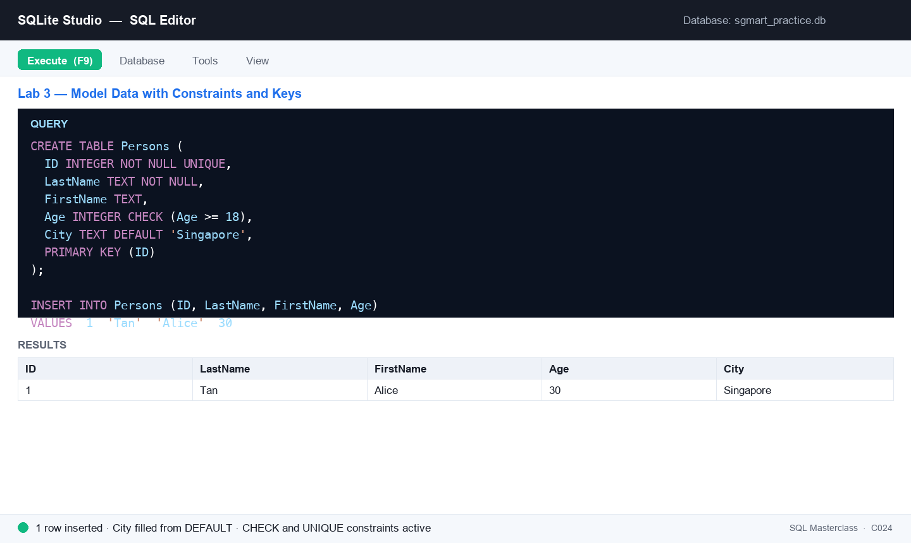
Figure 3 — Lab 3: the SQL editor after running this lab's key statement.
Step-by-step
Step 1. In the sgmart_practice database's SQL editor, create a Persons table that enforces NOT NULL, UNIQUE, DEFAULT and CHECK rules. SG Mart only issues accounts to adults, so Age must be 18 or over.
DROP TABLE IF EXISTS Persons;
CREATE TABLE Persons (
ID INTEGER NOT NULL UNIQUE,
LastName TEXT NOT NULL,
FirstName TEXT,
Age INTEGER CHECK (Age >= 18),
City TEXT DEFAULT 'Singapore',
Email TEXT,
PRIMARY KEY (ID)
);
Step 2. Prove the constraints work: this insert succeeds and fills City with the default value.
INSERT INTO Persons (ID, LastName, FirstName, Age)
VALUES (1, 'Tan', 'Alice', 30);
SELECT * FROM Persons;
Step 3. Now try to break the rules — each of these statements must FAIL (duplicate ID, NULL LastName, under-age CHECK). Run them one at a time and read the error message.
INSERT INTO Persons (ID, LastName, Age) VALUES (1, 'Lim', 25);
INSERT INTO Persons (ID, Age) VALUES (2, 40);
INSERT INTO Persons (ID, LastName, Age) VALUES (3, 'Lee', 15);
Step 4. Load the rest of the mock people from this lab's dataset — run seed_sqlite.sql, or paste these rows. Note Divya Kumar and Priya Nair have no email on file (NULL).
INSERT INTO Persons (ID, LastName, FirstName, Age, City, Email) VALUES
(2, 'Lim', 'Bryan', 42, 'Singapore', 'bryan.lim@example.com'),
(3, 'Kumar', 'Divya', 27, 'Singapore', NULL),
(4, 'Wong', 'Cheryl', 35, 'Johor Bahru', 'cheryl.wong@example.com'),
(5, 'Ibrahim', 'Hafiz', 24, 'Singapore', 'hafiz.ibrahim@example.com'),
(6, 'Lee', 'Marcus', 51, 'Singapore', 'marcus.lee@example.com'),
(7, 'Nair', 'Priya', 38, 'Singapore', NULL),
(8, 'Goh', 'Wei Ming', 19, 'Singapore', 'weiming.goh@example.com');
Step 5. Create the PersonOrders table whose PersonID column is a FOREIGN KEY referencing Persons — the child table pointing at the parent.
DROP TABLE IF EXISTS PersonOrders;
CREATE TABLE PersonOrders (
OrderID INTEGER NOT NULL,
OrderNumber INTEGER NOT NULL,
PersonID INTEGER,
OrderDate TEXT,
Amount REAL,
PRIMARY KEY (OrderID),
FOREIGN KEY (PersonID) REFERENCES Persons(ID)
);
Step 6. Load the order rows. The last one has a NULL PersonID — an order taken before the customer registered.
INSERT INTO PersonOrders VALUES
(1, 77895, 3, '2025-02-11', 128.40),
(2, 44678, 3, '2025-03-04', 56.90),
(3, 22456, 1, '2025-03-22', 312.75),
(4, 24562, 1, '2025-05-08', 89.20),
(5, 34764, 6, '2025-06-15', 204.60),
(6, 51230, 2, '2025-07-30', 47.85),
(7, 66120, 7, '2025-08-19', 156.30),
(8, 71984, NULL, '2025-09-02', 63.10);
Step 7. Check the relationship holds — list each order beside the person who placed it.
SELECT o.OrderNumber, p.FirstName, p.LastName, o.Amount
FROM PersonOrders o
INNER JOIN Persons p ON o.PersonID = p.ID
ORDER BY o.Amount DESC;
Step 8. Add a column to an existing table with ALTER TABLE.
ALTER TABLE Persons ADD MemberTier TEXT DEFAULT 'Basic';
Step 9. Create an index so searches on LastName are fast.
CREATE INDEX idx_lastname ON Persons (LastName);
Test it
The valid insert appears in Persons with City = 'Singapore'; the three rule-breaking inserts each raise a constraint error; the join returns 7 matched orders led by 312.75; PersonOrders shows a foreign key to Persons in its DDL; and idx_lastname is listed under Indexes.
Note: The same steps are in labs/lab-03-*/ in the course repository, alongside that lab's CSV data and SQL seed scripts.

Topic 02 — Data Processing and Analysis
SQL Queries · SQL Operators · Insert, Update & Delete
Key concepts
- Queries — SELECT retrieves data into a result-set; DISTINCT removes duplicates; WHERE filters rows.
- Operators — AND/OR/NOT, IN, BETWEEN, LIKE wildcards and IS NULL build precise filter conditions.
- Shaping results — ORDER BY sorts, LIMIT caps the row count, and aliases (AS) rename columns and tables.
- Changing data — INSERT INTO adds records, UPDATE modifies them and DELETE removes them — always with WHERE.

Lab 4 — Query Data with SELECT
Objective: LO2 — apply data processing and analysis using SQL queries.
Goal: Query the SG Mart product catalogue with SELECT: retrieve all columns, chosen columns, distinct values and filtered rows, then combine sorting and limits to answer real merchandising questions.
What you'll build
A set of working queries answering questions about SG Mart's products, categories and outlets. (Tools: SQLite Studio, sgmart database, lab-04 dataset.)
Mock data for this lab
Load the data before you start. The tables below are supplied as CSV in labs/lab-04-*/ — the same folder as this lab's instructions — together with seed_sqlite.sql. Open that script in the SQL editor and execute it to create and fill every table in one step.
Table | Rows | What it holds
Products | 25 | 25 SKUs with cost, retail price, category, supplier and reorder level (some NULL).
Categories | 8 | 8 product categories grouped into Perishables, Packaged and Non-Food.
Outlets | 8 | The 8 SG Mart retail outlets — code, name, planning area, postal sector, opening date and floor area.

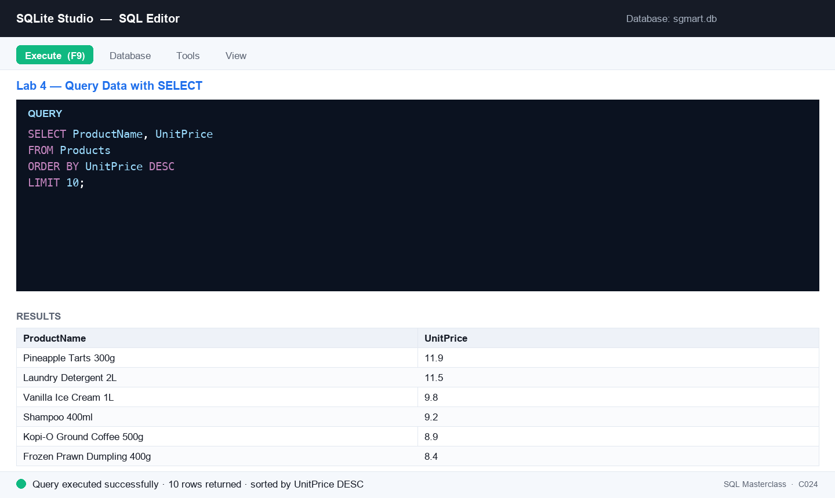
Figure 4 — Lab 4: the SQL editor after running this lab's key statement.
Step-by-step
Step 1. In the sgmart database's SQL editor, retrieve every row and column of Products, then only the columns a price list needs.
SELECT * FROM Products;
SELECT ProductName, UnitPrice FROM Products;
Step 2. List each category code just once with SELECT DISTINCT — how many distinct categories does the range span?
SELECT DISTINCT CategoryCode FROM Products;
Step 3. Filter rows with WHERE — every product supplied by Lion City Beverages (SUP05).
SELECT SKU, ProductName, UnitPrice
FROM Products
WHERE SupplierID = 'SUP05';
Step 4. Answer: what are the 10 most expensive products, dearest first?
SELECT ProductName, UnitPrice
FROM Products
ORDER BY UnitPrice DESC
LIMIT 10;
Step 5. Answer: which 5 outlets have the largest floor area, and in which district?
SELECT OutletName, District, FloorAreaSqm
FROM Outlets
ORDER BY FloorAreaSqm DESC
LIMIT 5;
Step 6. Combine a filter with a sort — active products under $5, cheapest first. This is the query a promotions planner actually runs.
SELECT ProductName, UnitPrice, CategoryCode
FROM Products
WHERE IsActive = 1
AND UnitPrice < 5.00
ORDER BY UnitPrice;
Test it
Each query runs without error; the DISTINCT query returns 8 category codes; the top-10 price query is led by Pineapple Tarts 300g at $11.90; and the largest outlet is SG Mart Tampines Hub (1680.5 sqm).
Note: The same steps are in labs/lab-04-*/ in the course repository, alongside that lab's CSV data and SQL seed scripts.

Lab 5 — Filter with SQL Operators
Objective: LO2 — analyse data with operators, patterns and sorting.
Goal: Sharpen your WHERE clauses with AND/OR/NOT, IN, BETWEEN, LIKE wildcards, NULL tests and aliases to slice the SG Mart customer and staff data precisely.
What you'll build
A query toolkit covering every SQL operator, answering pattern- and range-based questions on the SG Mart data. (Tools: SQLite Studio, sgmart database, lab-05 dataset.)
Mock data for this lab
Load the data before you start. The tables below are supplied as CSV in labs/lab-05-*/ — the same folder as this lab's instructions — together with seed_sqlite.sql. Open that script in the SQL editor and execute it to create and fill every table in one step.
Table | Rows | What it holds
Customers | 60 | 60 loyalty members — tier, join date, points, birth year (some NULL) and home district.
Products | 25 | 25 SKUs with cost, retail price, category, supplier and reorder level (some NULL).
Staff | 42 | 42 employees across the 8 outlets — role, salary, hire date and contact details (some emails are NULL on purpose).

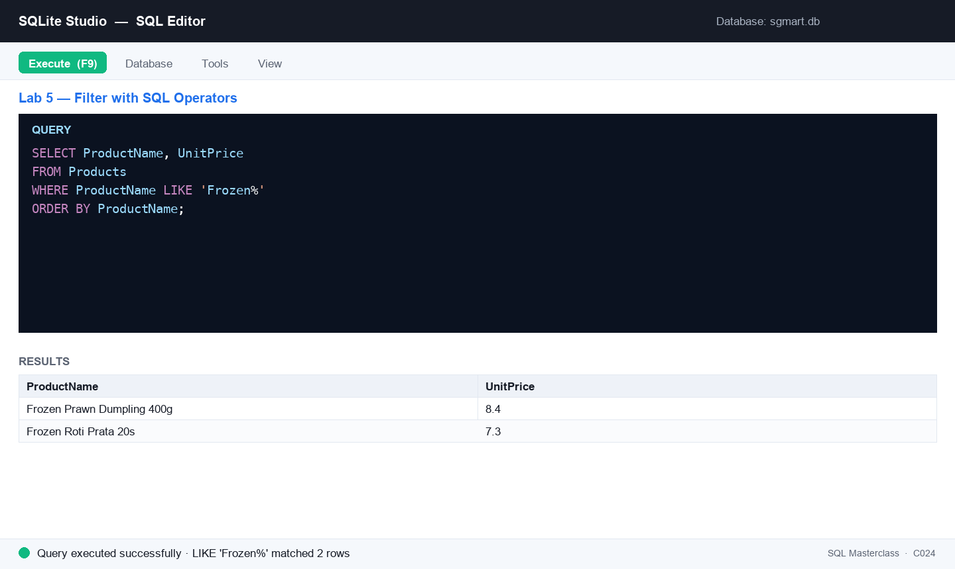
Figure 5 — Lab 5: the SQL editor after running this lab's key statement.
Step-by-step
Step 1. Combine conditions with AND — Store Managers earning more than $6,000 a month.
SELECT FirstName, LastName, Role, MonthlySalary
FROM Staff
WHERE Role = 'Store Manager'
AND MonthlySalary > 6000;
Step 2. Use OR and NOT — everyone who is NOT a Cashier but works part-time.
SELECT FirstName, LastName, Role, Employment
FROM Staff
WHERE NOT Role = 'Cashier'
AND Employment = 'Part-Time';
Step 3. Match a list of values with IN — members on the two premium tiers.
SELECT FirstName, LastName, MemberTier, PointsBalance
FROM Customers
WHERE MemberTier IN ('Gold', 'Platinum')
ORDER BY PointsBalance DESC;
Step 4. Select a range with BETWEEN — everyday products priced between $3 and $6.
SELECT ProductName, UnitPrice
FROM Products
WHERE UnitPrice BETWEEN 3.00 AND 6.00
ORDER BY UnitPrice;
Step 5. Find patterns with LIKE — every frozen line (the % wildcard matches any characters).
SELECT ProductName, UnitPrice
FROM Products
WHERE ProductName LIKE 'Frozen%'
ORDER BY ProductName;
Step 6. LIKE also matches mid-string — anything sold in a bottle, whatever the size.
SELECT ProductName, UnitOfMeasure
FROM Products
WHERE UnitOfMeasure LIKE '%bottle%';
Step 7. Test for missing values with IS NULL — staff with no work email on file — and rename a column with an alias.
SELECT FirstName || ' ' || LastName AS StaffName,
Role AS JobTitle,
Email
FROM Staff
WHERE Email IS NULL;
Step 8. The opposite test — members who DID give a birth year, so marketing can run a birthday campaign.
SELECT FirstName, LastName, BirthYear
FROM Customers
WHERE BirthYear IS NOT NULL
ORDER BY BirthYear
LIMIT 10;
Test it
The IN query returns 16 Gold and Platinum members ordered by points; BETWEEN returns 11 products from $3.20 to $5.95; LIKE 'Frozen%' returns the 2 frozen lines; and IS NULL returns the 5 staff with no email, shown under the alias StaffName.
Note: The same steps are in labs/lab-05-*/ in the course repository, alongside that lab's CSV data and SQL seed scripts.

Lab 6 — Insert, Update and Delete Records
Objective: LO2 — process data by inserting, updating and deleting records.
Goal: Change data safely: INSERT a new product line, UPDATE prices with a WHERE clause, DELETE a discontinued record, and reload the dataset from the provided seed script.
What you'll build
A modified Products table proving you can add, change and remove records — plus a cleanly reloaded database. (Tools: SQLite Studio, sgmart database, lab-06 seed script.)
Mock data for this lab
Load the data before you start. The tables below are supplied as CSV in labs/lab-06-*/ — the same folder as this lab's instructions — together with seed_sqlite.sql. Open that script in the SQL editor and execute it to create and fill every table in one step.
Table | Rows | What it holds
Products | 25 | 25 SKUs with cost, retail price, category, supplier and reorder level (some NULL).
Customers | 60 | 60 loyalty members — tier, join date, points, birth year (some NULL) and home district.
Orders | 180 | 180 sales orders across 2025 — outlet, member (NULL for walk-ins), cashier, channel, payment and status.

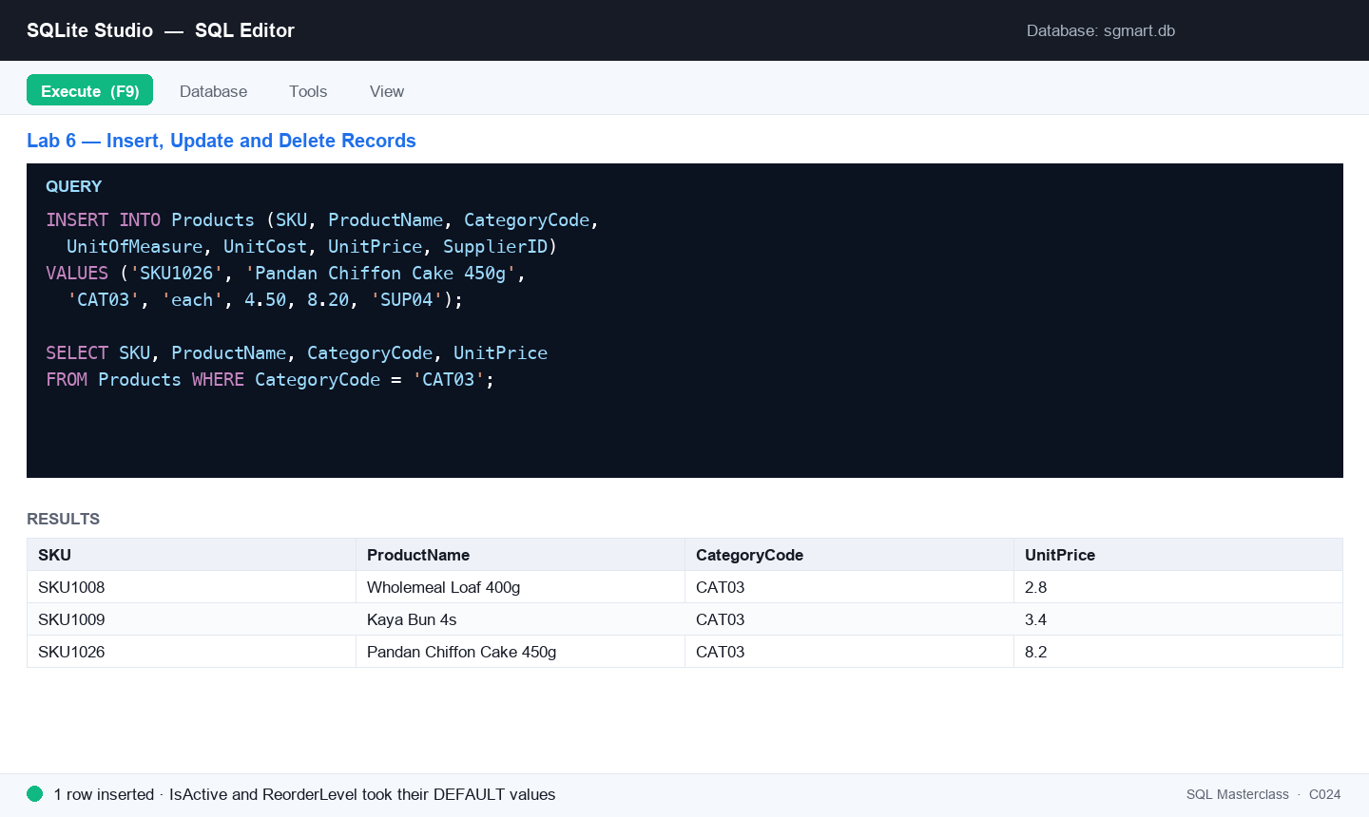
Figure 6 — Lab 6: the SQL editor after running this lab's key statement.
Step-by-step
Step 1. SG Mart is adding a new bakery line. Insert it, supplying just the columns you know — the rest take their defaults.
INSERT INTO Products (SKU, ProductName, CategoryCode, UnitOfMeasure, UnitCost, UnitPrice, SupplierID)
VALUES ('SKU1026', 'Pandan Chiffon Cake 450g', 'CAT03', 'each', 4.50, 8.20, 'SUP04');
Step 2. Verify the insert — find your new row.
SELECT * FROM Products WHERE SKU = 'SKU1026';
Step 3. Insert several rows in one statement — three new members joining at the Punggol launch.
INSERT INTO Customers (CustomerID, FirstName, LastName, MemberTier, JoinDate, PointsBalance, BirthYear, District, Phone, Email)
VALUES
(1061, 'Wei Jie', 'Tan', 'Basic', '2025-11-02', 0, 1996, 'Punggol', '9123 4567', 'weijie.tan@example.com'),
(1062, 'Nur Syahirah', 'Osman', 'Basic', '2025-11-02', 50, 1990, 'Punggol', '8234 5678', NULL),
(1063, 'Divya', 'Menon', 'Silver', '2025-11-03', 1200, 1988, 'Sengkang', '9345 6789', 'divya.menon@example.com');
Step 4. Update records with a WHERE clause — a 10% price rise on every Beverages line. Always SELECT first to see what you are about to change.
SELECT ProductName, UnitPrice FROM Products WHERE CategoryCode = 'CAT04';

UPDATE Products
SET UnitPrice = ROUND(UnitPrice * 1.10, 2)
WHERE CategoryCode = 'CAT04';

SELECT ProductName, UnitPrice FROM Products WHERE CategoryCode = 'CAT04';
Step 5. Update more than one column at once — promote a member and credit bonus points.
UPDATE Customers
SET MemberTier = 'Gold',
PointsBalance = PointsBalance + 500
WHERE CustomerID = 1063;
Step 6. Delete one specific record by its primary key. (Never run DELETE without WHERE — it removes every row.)
DELETE FROM Products WHERE SKU = 'SKU1026';
Step 7. Delete a set of rows with a condition — clear out the cancelled orders.
SELECT COUNT(*) FROM Orders WHERE Status = 'Cancelled';
DELETE FROM Orders WHERE Status = 'Cancelled';
Step 8. Restore the database to its original state: open seed_sqlite.sql from this lab's dataset folder and execute it. The script drops and recreates every table, so your practice changes are undone.
Step 9. Confirm the reload with row counts.
SELECT COUNT(*) AS Products FROM Products;
SELECT COUNT(*) AS Customers FROM Customers;
SELECT COUNT(*) AS Orders FROM Orders;
Test it
The SKU1026 row appears after the INSERT and is gone after the DELETE; the three new members are added; Beverages prices rise by 10% (Sparkling Water 1.5L goes from 2.35 to 2.59); and after reloading, the counts return 25 products, 60 customers and 180 orders.
Note: The same steps are in labs/lab-06-*/ in the course repository, alongside that lab's CSV data and SQL seed scripts.

Topic 03 — Data Transformation
Aggregate Data · Join Data · Group Data
Key concepts
- Aggregate functions — COUNT, AVG and SUM collapse many rows into one summary value.
- Joins — INNER, LEFT, RIGHT and FULL OUTER joins combine rows from two tables on a matching key.
- Set operations — UNION stacks the result-sets of two SELECTs with matching columns.
- Grouping — GROUP BY aggregates per group; HAVING filters groups the way WHERE filters rows.

Lab 7 — Aggregate Data with COUNT, AVG and SUM
Objective: LO3 — transform data with aggregate functions.
Goal: Summarise SG Mart's sales with COUNT, AVG, SUM, MIN and MAX: count transactions, average basket values, total revenue, and combine aggregates with DISTINCT and WHERE to answer real management questions.
What you'll build
A management summary of SG Mart trading — order counts, average and total revenue, and filtered aggregate answers. (Tools: SQLite Studio, sgmart database, lab-07 dataset.)
Mock data for this lab
Load the data before you start. The tables below are supplied as CSV in labs/lab-07-*/ — the same folder as this lab's instructions — together with seed_sqlite.sql. Open that script in the SQL editor and execute it to create and fill every table in one step.
Table | Rows | What it holds
Orders | 180 | 180 sales orders across 2025 — outlet, member (NULL for walk-ins), cashier, channel, payment and status.
OrderItems | 685 | Order lines (the fact table) — quantity, unit price, discount and line total. Makes SUM/AVG/GROUP BY meaningful.
Products | 25 | 25 SKUs with cost, retail price, category, supplier and reorder level (some NULL).

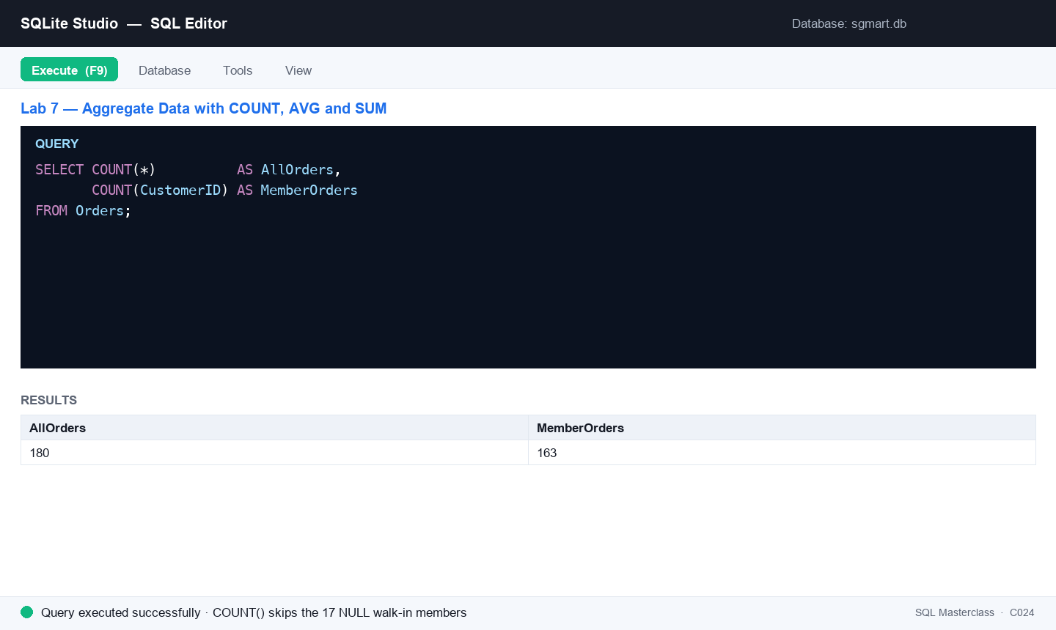
Figure 7 — Lab 7: the SQL editor after running this lab's key statement.
Step-by-step
Step 1. Count the rows in Orders — how many transactions did SG Mart record in 2025?
SELECT COUNT(*) AS TotalOrders FROM Orders;
Step 2. COUNT ignores NULLs, and that is useful. Compare these two — the difference is the walk-in customers with no membership.
SELECT COUNT(*) AS AllOrders,
COUNT(CustomerID) AS MemberOrders
FROM Orders;
Step 3. Average a numeric column — the mean value of a sales line.
SELECT ROUND(AVG(LineTotal), 2) AS AvgLineValue
FROM OrderItems;
Step 4. Total a numeric column — SG Mart's full-year revenue.
SELECT ROUND(SUM(LineTotal), 2) AS TotalRevenue
FROM OrderItems;
Step 5. MIN and MAX bracket the range — the cheapest and dearest thing on the shelf.
SELECT MIN(UnitPrice) AS Cheapest,
MAX(UnitPrice) AS Dearest
FROM Products;
Step 6. Answer: how many distinct payment methods do customers actually use?
SELECT COUNT(DISTINCT PaymentMethod) AS PaymentMethods
FROM Orders;
Step 7. Answer: how many orders were completed, as opposed to refunded or cancelled?
SELECT COUNT(*) AS CompletedOrders
FROM Orders
WHERE Status = 'Completed';
Step 8. Put it together — the average basket for online orders only, rounded to cents.
SELECT ROUND(AVG(oi.LineTotal), 2) AS AvgOnlineLine,
COUNT(*) AS OnlineLines
FROM Orders o
INNER JOIN OrderItems oi ON o.OrderID = oi.OrderID
WHERE o.Channel = 'Online';
Test it
COUNT(*) returns 180 orders while COUNT(CustomerID) returns 163 (17 walk-ins are NULL); average line value is 13.48; total revenue is 9231.43; prices range from 2.10 to 11.90; and there are 5 distinct payment methods with 165 completed orders.
Note: The same steps are in labs/lab-07-*/ in the course repository, alongside that lab's CSV data and SQL seed scripts.

Lab 8 — Join Data from Multiple Tables
Objective: LO3 — transform data from multiple sources with joins and unions.
Goal: Combine tables: INNER JOIN orders to outlets and products, see how LEFT JOIN keeps the walk-in orders that have no member, chain three joins together, and emulate a FULL OUTER JOIN in SQLite using LEFT JOIN + UNION.
What you'll build
Joined result-sets linking orders, outlets, customers and products, plus a full-outer-join of two practice tables showing matched and unmatched rows. (Tools: SQLite Studio, sgmart database, lab-08 dataset.)
Mock data for this lab
Load the data before you start. The tables below are supplied as CSV in labs/lab-08-*/ — the same folder as this lab's instructions — together with seed_sqlite.sql. Open that script in the SQL editor and execute it to create and fill every table in one step.
Table | Rows | What it holds
Orders | 180 | 180 sales orders across 2025 — outlet, member (NULL for walk-ins), cashier, channel, payment and status.
OrderItems | 685 | Order lines (the fact table) — quantity, unit price, discount and line total. Makes SUM/AVG/GROUP BY meaningful.
Customers | 60 | 60 loyalty members — tier, join date, points, birth year (some NULL) and home district.
Outlets | 8 | The 8 SG Mart retail outlets — code, name, planning area, postal sector, opening date and floor area.
Products | 25 | 25 SKUs with cost, retail price, category, supplier and reorder level (some NULL).
left_t | 4 | Practice table for the FULL OUTER JOIN emulation (ids 1-4).
right_t | 4 | Practice table for the FULL OUTER JOIN emulation (ids 3-6).

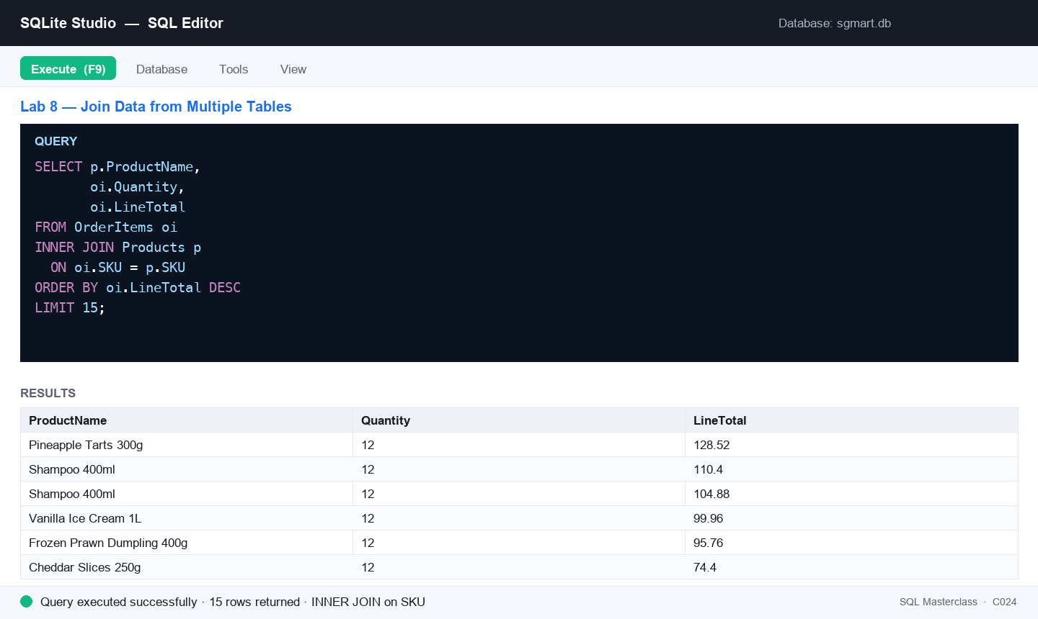
Figure 8 — Lab 8: the SQL editor after running this lab's key statement.
Step-by-step
Step 1. Inner join Orders and Outlets on the outlet code — each order with the branch that took it.
SELECT o.OrderID, o.OrderDate, ot.OutletName, ot.District
FROM Orders o
INNER JOIN Outlets ot
ON o.OutletCode = ot.OutletCode
LIMIT 20;
Step 2. Join the fact table to the item master — what was actually sold, line by line.
SELECT oi.OrderID,
p.ProductName,
oi.Quantity,
oi.LineTotal
FROM OrderItems oi
INNER JOIN Products p
ON oi.SKU = p.SKU
ORDER BY oi.LineTotal DESC
LIMIT 15;
Step 3. LEFT JOIN keeps every row of the left table even without a match — every order, with the member's name where there is one. Walk-ins show NULL.
SELECT o.OrderID, o.OrderDate,
c.FirstName, c.LastName
FROM Orders o
LEFT JOIN Customers c
ON o.CustomerID = c.CustomerID
ORDER BY o.OrderID
LIMIT 25;
Step 4. Isolate the unmatched rows — this is the standard 'find the orphans' pattern.
SELECT COUNT(*) AS WalkInOrders
FROM Orders o
LEFT JOIN Customers c
ON o.CustomerID = c.CustomerID
WHERE c.CustomerID IS NULL;
Step 5. Chain three joins to answer a real question: which outlet sold which product, and for how much?
SELECT ot.OutletName,
p.ProductName,
ROUND(SUM(oi.LineTotal), 2) AS Revenue
FROM Orders o
INNER JOIN Outlets ot ON o.OutletCode = ot.OutletCode
INNER JOIN OrderItems oi ON o.OrderID = oi.OrderID
INNER JOIN Products p ON oi.SKU = p.SKU
GROUP BY ot.OutletName, p.ProductName
ORDER BY Revenue DESC
LIMIT 10;
Step 6. Create two small practice tables to demonstrate a full outer join.
DROP TABLE IF EXISTS left_t;
DROP TABLE IF EXISTS right_t;
CREATE TABLE left_t ( id INTEGER, description TEXT );
CREATE TABLE right_t ( id INTEGER, description TEXT );
INSERT INTO left_t VALUES (1,'left 01'),(2,'left 02'),(3,'left 03'),(4,'left 04');
INSERT INTO right_t VALUES (3,'right 03'),(4,'right 04'),(5,'right 05'),(6,'right 06');
Step 7. Older SQLite builds have no FULL OUTER JOIN keyword — emulate it with a LEFT JOIN in each direction combined by UNION. Alias every output column: after a UNION, ORDER BY can only refer to the result-set column names, so 'ORDER BY id' fails unless you name the column id.
SELECT l.id AS id,
l.description AS left_desc,
r.description AS right_desc
FROM left_t l LEFT JOIN right_t r ON l.id = r.id
UNION
SELECT r.id AS id,
l.description AS left_desc,
r.description AS right_desc
FROM right_t r LEFT JOIN left_t l ON l.id = r.id
ORDER BY id;
Test it
The inner joins return only matched rows; the LEFT JOIN lists every order with NULL names for walk-ins and the orphan count returns 17; the three-way join is led by SG Mart outlets selling Pineapple Tarts; and the full-join emulation returns ids 1–6 with NULLs on the sides that have no match.
Note: The same steps are in labs/lab-08-*/ in the course repository, alongside that lab's CSV data and SQL seed scripts.

Lab 9 — Group Data with GROUP BY and HAVING
Objective: LO3 — transform data by grouping and filtering groups.
Goal: Aggregate per group: revenue by outlet and by category with GROUP BY, then keep only the groups that matter with HAVING — and see why HAVING exists where WHERE cannot go.
What you'll build
Grouped sales summaries of the SG Mart data — per-outlet and per-category totals, filtered to the groups that matter. (Tools: SQLite Studio, sgmart database, lab-09 dataset.)
Mock data for this lab
Load the data before you start. The tables below are supplied as CSV in labs/lab-09-*/ — the same folder as this lab's instructions — together with seed_sqlite.sql. Open that script in the SQL editor and execute it to create and fill every table in one step.
Table | Rows | What it holds
Orders | 180 | 180 sales orders across 2025 — outlet, member (NULL for walk-ins), cashier, channel, payment and status.
OrderItems | 685 | Order lines (the fact table) — quantity, unit price, discount and line total. Makes SUM/AVG/GROUP BY meaningful.
Products | 25 | 25 SKUs with cost, retail price, category, supplier and reorder level (some NULL).
Categories | 8 | 8 product categories grouped into Perishables, Packaged and Non-Food.
Outlets | 8 | The 8 SG Mart retail outlets — code, name, planning area, postal sector, opening date and floor area.

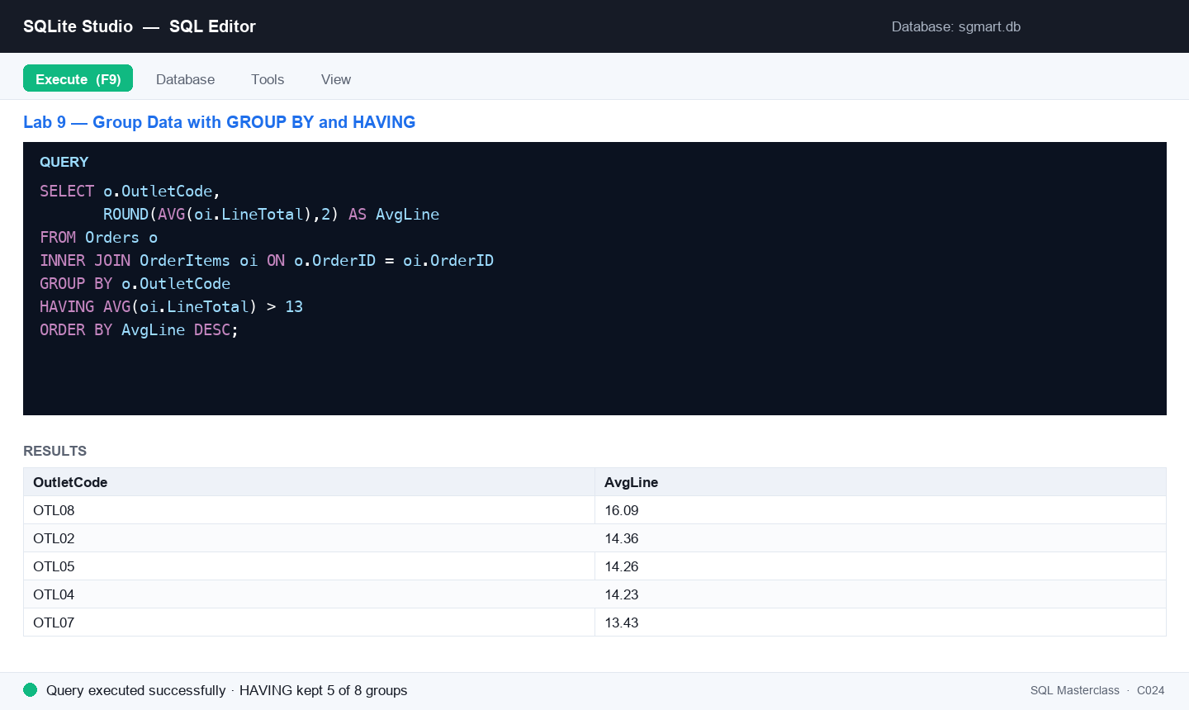
Figure 9 — Lab 9: the SQL editor after running this lab's key statement.
Step-by-step
Step 1. Count the orders taken by each outlet — one row per group.
SELECT OutletCode, COUNT(*) AS Orders
FROM Orders
GROUP BY OutletCode
ORDER BY Orders DESC;
Step 2. Group across a join — total revenue per outlet, with a readable name and alias.
SELECT ot.OutletName,
ROUND(SUM(oi.LineTotal), 2) AS Revenue
FROM Orders o
INNER JOIN Outlets ot ON o.OutletCode = ot.OutletCode
INNER JOIN OrderItems oi ON o.OrderID = oi.OrderID
GROUP BY ot.OutletName
ORDER BY Revenue DESC;
Step 3. Group by a different dimension — how customers prefer to pay.
SELECT PaymentMethod, COUNT(*) AS Orders
FROM Orders
GROUP BY PaymentMethod
ORDER BY Orders DESC;
Step 4. Keep only the groups whose average line exceeds $13 — WHERE cannot filter aggregates, HAVING can.
SELECT o.OutletCode,
ROUND(AVG(oi.LineTotal), 2) AS AvgLine
FROM Orders o
INNER JOIN OrderItems oi ON o.OrderID = oi.OrderID
GROUP BY o.OutletCode
HAVING AVG(oi.LineTotal) > 13
ORDER BY AvgLine DESC;
Step 5. Find your loyal customers — members who placed 4 or more orders.
SELECT c.FirstName, c.LastName, c.MemberTier,
COUNT(*) AS Orders
FROM Orders o
INNER JOIN Customers c ON o.CustomerID = c.CustomerID
GROUP BY c.CustomerID, c.FirstName, c.LastName, c.MemberTier
HAVING COUNT(*) >= 4
ORDER BY Orders DESC;
Step 6. Use all three clauses together — WHERE filters rows BEFORE grouping, HAVING filters groups AFTER. Revenue by category for completed orders only, keeping the categories above $1,000.
SELECT cat.CategoryName,
ROUND(SUM(oi.LineTotal), 2) AS Revenue,
COUNT(*) AS Lines
FROM Orders o
INNER JOIN OrderItems oi ON o.OrderID = oi.OrderID
INNER JOIN Products p ON oi.SKU = p.SKU
INNER JOIN Categories cat ON p.CategoryCode = cat.CategoryCode
WHERE o.Status = 'Completed'
GROUP BY cat.CategoryName
HAVING SUM(oi.LineTotal) > 1000
ORDER BY Revenue DESC;
Test it
The GROUP BY query returns one row per outlet (8 rows, led by OTL08 with 28 orders); revenue by outlet is led by SG Mart Serangoon NEX at 1496.82; the HAVING > 13 query returns the 5 qualifying outlets; and 18 members have 4 or more orders.
Note: The same steps are in labs/lab-09-*/ in the course repository, alongside that lab's CSV data and SQL seed scripts.

Topic 04 — Introduction to Data Warehouse
Overview of Data Warehouse · Relational Databases · Stored Procedures
Key concepts
- Data warehouse — A consolidated, historical, read-mostly database kept separate from operational systems for analysis.
- OLAP vs OLTP — OLAP serves complex analytical queries; OLTP serves fast day-to-day transactions.
- RDBMS & E-R model — The relational model plus entity-relationship design maps business entities to tables and keys.
- Stored procedures — Prepared SQL saved on the server (SQL Server) for reuse — callable with parameters via EXEC.

Lab 10 — Map an E-R Model to Database Tables (SMRT Case Study)
Objective: LO4 — apply data mapping from an E-R model to a data warehouse schema.
Goal: Take the SMRT public-transport E-R model (Routes, Stations, Timetables, DisruptedRoutes) and map it to physical tables: create each entity with its primary key, wire the foreign-key relationships, load the mock operational data and verify the model with joined queries.
What you'll build
A four-table transport schema in SQLite that faithfully implements the SMRT E-R model with PK/FK mappings, loaded with real-shaped route, timetable and disruption data. (Tools: SQLite Studio, sgmart_practice database, lab-10 dataset (Routes, Stations, Timetables, DisruptedRoutes).)
Mock data for this lab
Load the data before you start. The tables below are supplied as CSV in labs/lab-10-*/ — the same folder as this lab's instructions — together with seed_sqlite.sql. Open that script in the SQL editor and execute it to create and fill every table in one step.
Table | Rows | What it holds
Routes | 8 | 8 SMRT routes (6 MRT lines + 2 bus services) — the parent entity of the transport E-R model.
Stations | 14 | 14 MRT stations with line position, interchange flag and opening date.
Timetables | 42 | 42 timetable rows — first/last trip and frequency per station for weekday, Saturday and Sunday/PH.
DisruptedRoutes | 6 | 6 service disruptions in 2025 — type, details, start time, duration and the alternative arrangements offered.

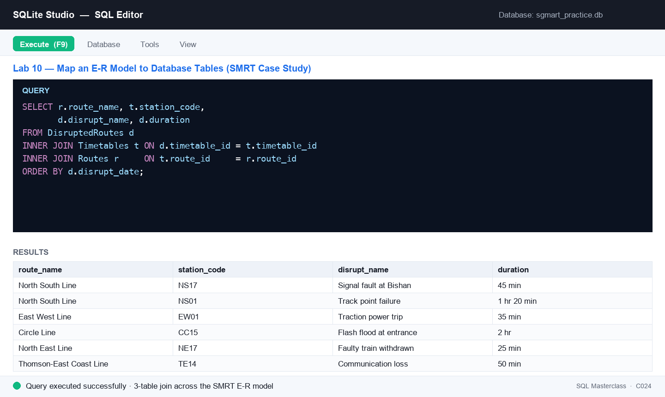
Figure 10 — Lab 10: the SQL editor after running this lab's key statement.
Step-by-step
Step 1. Review the E-R model before writing any SQL. Routes (route_id PK) 1—many Stations and 1—many Timetables (timetable_id PK, route_id FK); Timetables 1—many DisruptedRoutes (disrupt_no PK, timetable_id FK). Identify each entity's attributes, its primary key, and which column carries the relationship.
Step 2. Create the Routes parent table — the 6 MRT lines and 2 bus services.
DROP TABLE IF EXISTS Routes;
CREATE TABLE Routes (
route_id CHARACTER(4) NOT NULL PRIMARY KEY,
route_type CHARACTER(15) NOT NULL,
route_code VARCHAR(3) NOT NULL,
route_name VARCHAR(125) NOT NULL,
route_direction CHARACTER(10) NOT NULL,
remarks VARCHAR(255)
);
Step 3. Create the Stations table — each station belongs to one route, so route_id is a FOREIGN KEY.
DROP TABLE IF EXISTS Stations;
CREATE TABLE Stations (
station_code CHARACTER(4) NOT NULL PRIMARY KEY,
station_name VARCHAR(40) NOT NULL,
route_id CHARACTER(4) NOT NULL,
line_position INTEGER NOT NULL,
is_interchange INTEGER NOT NULL DEFAULT 0,
opened_date DATE,
FOREIGN KEY (route_id) REFERENCES Routes(route_id)
);
Step 4. Create the Timetables child table — first and last trip per station for each service pattern.
DROP TABLE IF EXISTS Timetables;
CREATE TABLE Timetables (
timetable_id INTEGER NOT NULL PRIMARY KEY,
route_id CHARACTER(4) NOT NULL,
station_code CHARACTER(4) NOT NULL,
frequency VARCHAR(20) DEFAULT '',
days_operation VARCHAR(30) NOT NULL,
stop_no NUMERIC(3) NOT NULL,
first_trip CHAR(10) NOT NULL,
last_trip CHAR(10) NOT NULL,
FOREIGN KEY (route_id) REFERENCES Routes(route_id)
);
Step 5. Create the DisruptedRoutes table — its timetable_id references Timetables, completing the chain.
DROP TABLE IF EXISTS DisruptedRoutes;
CREATE TABLE DisruptedRoutes (
disrupt_no INTEGER NOT NULL PRIMARY KEY,
disrupt_date DATE NOT NULL,
disrupt_type VARCHAR(20) NOT NULL,
disrupt_name VARCHAR(50) NOT NULL,
disrupt_details VARCHAR(300) NOT NULL,
start_datetime CHAR(12) NOT NULL,
duration CHAR(20) NOT NULL,
timetable_id INTEGER NOT NULL,
alternatives VARCHAR(3000) NOT NULL,
FOREIGN KEY (timetable_id) REFERENCES Timetables(timetable_id)
);
Step 6. Load the operational data: open seed_sqlite.sql from this lab's dataset folder and execute it. It fills all four tables — 8 routes, 14 stations, 42 timetable rows and 6 recorded disruptions.
Step 7. Verify the parent table loaded and the model reads correctly.
SELECT route_id, route_code, route_name, route_type
FROM Routes
ORDER BY route_id;
Step 8. Walk one relationship — every station on the North South Line, in line order.
SELECT s.station_code, s.station_name, s.line_position, s.is_interchange
FROM Stations s
INNER JOIN Routes r ON s.route_id = r.route_id
WHERE r.route_code = 'NSL'
ORDER BY s.line_position;
Step 9. Verify the mapping end-to-end: join all the way from a disruption back to its route.
SELECT r.route_name,
t.station_code,
t.days_operation,
d.disrupt_name,
d.duration
FROM DisruptedRoutes d
INNER JOIN Timetables t ON d.timetable_id = t.timetable_id
INNER JOIN Routes r ON t.route_id = r.route_id
ORDER BY d.disrupt_date;
Step 10. Now analyse it like a warehouse would — which route type suffers the most disruptions?
SELECT r.route_name,
COUNT(d.disrupt_no) AS Disruptions
FROM Routes r
LEFT JOIN Timetables t ON r.route_id = t.route_id
LEFT JOIN DisruptedRoutes d ON t.timetable_id = d.timetable_id
GROUP BY r.route_name
ORDER BY Disruptions DESC;
Test it
The four tables exist with their PK/FK constraints visible in the DDL; Routes returns 8 rows; the NSL station query returns 4 stations in line order; the three-way join returns the 6 disruptions each linked to a route and station; and the LEFT JOIN summary lists every route including those with zero disruptions.
Note: The same steps are in labs/lab-10-*/ in the course repository, alongside that lab's CSV data and SQL seed scripts.

Lab 11 — Author Stored Procedures for SQL Server
Objective: LO4 — operate data-warehouse platform capabilities with reusable stored procedures.
Goal: Write stored procedures in SQL Server syntax against the SG Mart data — a plain procedure and a parameterised one — and understand where they run (SQL Server / MySQL, not SQLite) and why warehouses use them for repeatable batch work.
What you'll build
Stored-procedure scripts (plain and parameterised) ready to run on SQL Server, plus the EXEC calls that invoke them. (Tools: SQL Editor, SQL Server syntax (sqliteonline.com's MS SQL engine, or any SQL Server), lab-11 dataset (seed_mysql.sql).)
Mock data for this lab
Load the data before you start. The tables below are supplied as CSV in labs/lab-11-*/ — the same folder as this lab's instructions — together with seed_sqlite.sql. Open that script in the SQL editor and execute it to create and fill every table in one step.
Table | Rows | What it holds
Customers | 60 | 60 loyalty members — tier, join date, points, birth year (some NULL) and home district.
Orders | 180 | 180 sales orders across 2025 — outlet, member (NULL for walk-ins), cashier, channel, payment and status.
Outlets | 8 | The 8 SG Mart retail outlets — code, name, planning area, postal sector, opening date and floor area.

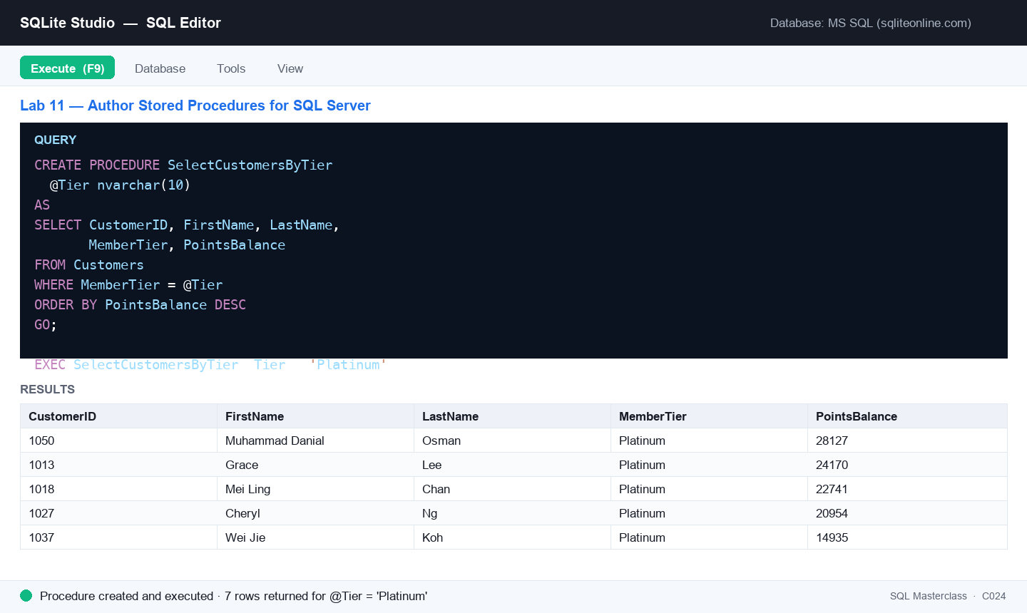
Figure 11 — Lab 11: the SQL editor after running this lab's key statement.
Step-by-step
Step 1. Stored procedures are not available in SQLite — author these against SQL Server. Free option: open sqliteonline.com and switch the engine to MS SQL. Load this lab's seed_mysql.sql to create the Customers, Orders and Outlets tables with the SG Mart data.
Step 2. A stored procedure is a named, saved SQL script the server keeps for you. Write one that returns all members, then run it to save it.
CREATE PROCEDURE SelectAllCustomers
AS
SELECT CustomerID, FirstName, LastName, MemberTier, PointsBalance
FROM Customers
GO;
Step 3. Execute the stored procedure by name — no need to retype the query.
EXEC SelectAllCustomers;
Step 4. Write a parameterised version that filters members by tier through a @Tier parameter. Parameters are what make a procedure reusable.
CREATE PROCEDURE SelectCustomersByTier
@Tier nvarchar(10)
AS
SELECT CustomerID, FirstName, LastName, MemberTier, PointsBalance
FROM Customers
WHERE MemberTier = @Tier
ORDER BY PointsBalance DESC
GO;
Step 5. Execute it, passing the parameter value — then run it again with a different tier to see the same procedure answer a different question.
EXEC SelectCustomersByTier @Tier = 'Platinum';
EXEC SelectCustomersByTier @Tier = 'Gold';
Step 6. Write a procedure with two parameters — the pattern a nightly warehouse job would use to extract one outlet's takings for a date range.
CREATE PROCEDURE OutletSalesByPeriod
@Outlet nvarchar(5),
@FromDate date
AS
SELECT o.OutletCode,
COUNT(*) AS Orders,
MAX(o.OrderDate) AS LatestOrder
FROM Orders o
WHERE o.OutletCode = @Outlet
AND o.OrderDate >= @FromDate
GROUP BY o.OutletCode
GO;
Step 7. Run the two-parameter procedure.
EXEC OutletSalesByPeriod @Outlet = 'OTL08', @FromDate = '2025-07-01';
Step 8. Discuss: why do data warehouses rely on stored procedures? They centralise the logic, run close to the data (no network round-trips), can be granted to users without exposing the base tables, and give you one place to change a rule.
Test it
All three procedures create without error; EXEC SelectAllCustomers returns the full 60-member list; EXEC SelectCustomersByTier @Tier = 'Platinum' returns only the 7 Platinum members ordered by points; and the two-parameter procedure returns one summary row for OTL08.
Note: The same steps are in labs/lab-11-*/ in the course repository, alongside that lab's CSV data and SQL seed scripts.

SQL Quick Reference
The statements taught in this course, in one place. All run in SQLite unless marked otherwise.
Define structure (DDL)
CREATE DATABASE dbname; -- create a database (file in SQLite)
CREATE TABLE t (col TYPE constraint, ...); -- create a table
ALTER TABLE t ADD col TYPE; -- add a column
CREATE INDEX idx ON t (col); -- speed up searches
DROP TABLE t; DROP DATABASE dbname; -- delete (careful!)
Constraints
NOT NULL | UNIQUE | DEFAULT 'value' | CHECK (cond)
PRIMARY KEY (col)
FOREIGN KEY (col) REFERENCES parent(pk)
Query (DQL)
SELECT col1, col2 FROM t; -- chosen columns ( * = all )
SELECT DISTINCT col FROM t; -- unique values
SELECT * FROM t WHERE cond; -- filter rows
cond: = <> > < >= <= AND OR NOT
IN (v1,v2) BETWEEN a AND b
LIKE 'a%' IS NULL EXISTS (subquery)
SELECT col AS alias FROM t; -- rename in the result
ORDER BY col ASC|DESC LIMIT n -- sort and cap
Change data (DML)
INSERT INTO t (c1,c2) VALUES (v1,v2);
UPDATE t SET c1 = v1 WHERE cond; -- ALWAYS use WHERE
DELETE FROM t WHERE cond; -- ALWAYS use WHERE
Transform (aggregate · join · group)
SELECT COUNT(c), AVG(c), SUM(c) FROM t WHERE cond;
SELECT ... FROM t1 INNER JOIN t2 ON t1.k = t2.k;
SELECT ... FROM t1 LEFT JOIN t2 ON t1.k = t2.k;
SELECT ... UNION SELECT ...; -- same columns both sides
GROUP BY col HAVING AGG(col) cond -- filter groups, not rows
Stored procedures (SQL Server — not SQLite)
CREATE PROCEDURE name @param type AS sql_statement GO;
EXEC name @param = value;

After the Course
- Redo every lab from memory in SQLite Studio — fluency comes from typing the SQL yourself.
- Point SQLite Studio at your own data: import a CSV into a table and analyse it with the Topic 2–3 queries.
- The same SQL works in MySQL, PostgreSQL and SQL Server — load seed_mysql.sql on a server engine and rerun the labs.
- Continue with the recommended courses at https://www.tertiarycourses.com.sg.
- Complete the course feedback form and collect your Certificate of Achievement from the trainer.

Glossary
- Database — An organised collection of data — in SQLite, a single .db file holding tables.
- Table — A collection of rows sharing the same columns (fields); the unit SQL queries operate on.
- Row / Record — One instance of a table's row type — the smallest unit inserted or deleted.
- Column / Field — A named, typed slot that every row of a table has.
- Result-set — The table of rows returned by a SELECT query.
- Constraint — A rule on a column (NOT NULL, UNIQUE, CHECK, DEFAULT, keys) enforced by the engine.
- Primary key — The column(s) that uniquely identify each row — UNIQUE + NOT NULL, one per table.
- Foreign key — A column referencing another table's primary key, linking child to parent.
- Index — A hidden structure that speeds up searches on the indexed column(s).
- Join — Combining rows of two tables on matching key values (INNER/LEFT/RIGHT/FULL).
- Aggregate function — COUNT, AVG, SUM, MIN, MAX — collapse many rows into one summary value.
- GROUP BY / HAVING — Aggregate per group of equal values / filter those groups.
- Data modeling — Designing entities, attributes and key relationships to mirror a business process.
- E-R model — Entity-Relationship model — the high-level diagram mapped into tables and keys.
- Data warehouse — A separate, consolidated, historical, read-mostly database for analysis and decisions.
- OLAP / OLTP — Analytical processing over the warehouse / transactional processing in operational systems.
- RDBMS — Relational Database Management System — the engine class SQL was built for.
- Stored procedure — Prepared SQL saved on the server (SQL Server/MySQL), executed by name with EXEC.
- SQL injection — Attacking a system by smuggling SQL through user input — prevented with parameterised queries.

